ESS - Attaching a Document in Case Management QRG

Attaching a document within Employee Self Service (ESS).

1. Within the home page, click on View Profile.

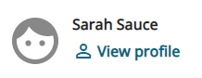

1. Within your profile, click on the Employment tab on the top bar.

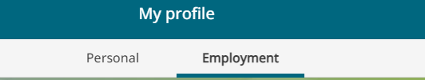

1. Scroll down and locate the Case Management section.
2. Locate your open case and click on the paperclip icon.

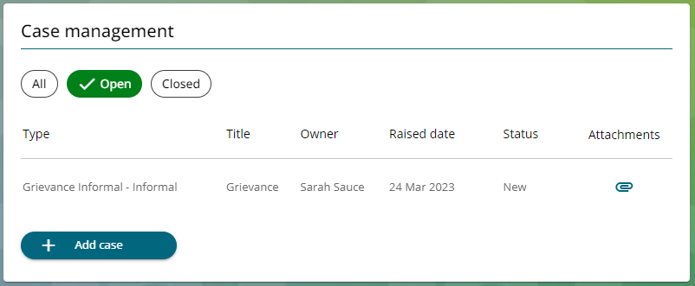

1. Click on +Add Attachments.
2. Within the Document name field, enter the document title – ie grievance information.
3. Within the Document type select HR.
4. Click on +Upload File.
5. You can either take a picture of your document by using your phone camera or you can upload from your files.

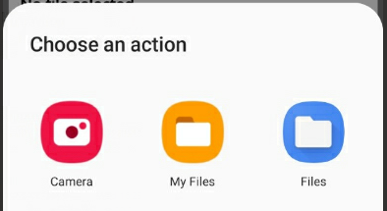

1. Click on the save button on the attachment page.

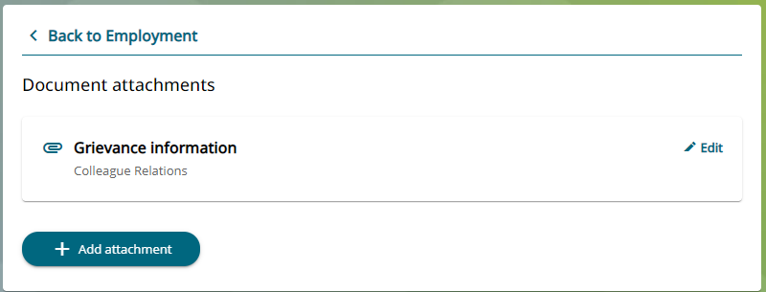

1. Once you have attached your document, the following message will appear.



1. You can view your attachments within Case Management by selecting the paperclip icon.
2. You can view these attachments at any time, or you can add further documents.

|  |  |  |  |
| --- | --- | --- | --- |
| Responsible (R) | Colleague Relations & Wellbeing | Accountable (A) | Human Resources |
| Consult (C) | Business Solutions | Inform (I) | All Business Units |
| Date | 18/08/2023 | Version | 1.0 |

1. An email will be sent to Colleague Relations confirming that you have attached a document.