ESS - Attaching a Medical Certificate QRG

If your sickness absence continues beyond 7 calendar days, you’ll need to provide a medical certificate(s) for the duration of the absence period. You must keep in regular contact with your manager and confirm your return date as soon as you know you’re fit to return.

**Attaching a Medical Certificate to your Sickness Absence record**

1. Within Employee Self-Service (ESS), click on My Time.
2. Within the Sickness page, click on View all Sickness.
3. To view your sickness records, remove the dates and click search.

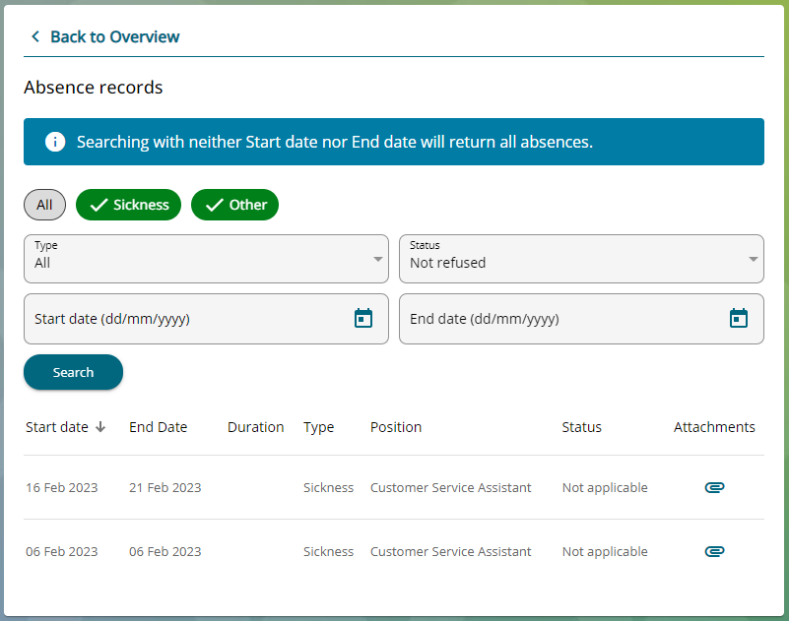

1. Locate the sickness absence record that is relevant to the medical certificate and scroll to the right and locate the paperclip icon.
2. Click on the paperclip to attach your medical certificate.
3. Click add attachment.



1. Within the document name, enter medical certificate and within the document type select Medical Certificate.
2. Click on the upload file button.



1. You can either take a picture of your medical certificate by using your phone’s camera or you can upload from your files.
2. Once you have attached your medical certificate, click save.
3. The following message will appear.



1. Your manager will receive an email to confirm that you have attached a medical certificate to the current sickness absence record.
2. Close the document attachment page.
3. You can now see that the medical certificate has been attached to the sickness absence record.

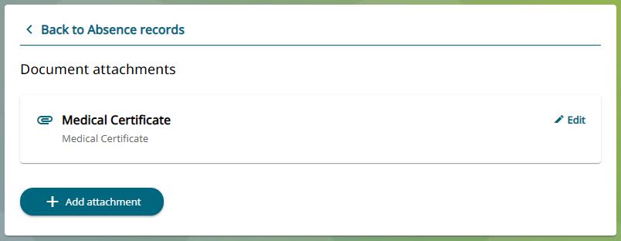

|  |  |  |  |
| --- | --- | --- | --- |
| Responsible (R) | Colleague Relations & Wellbeing | Accountable (A) | Human Resources |
| Consult (C) | Business Solutions | Inform (I) | All Business Units |
| Date | 18/08/2023 | Version | 1.0 |

1. To attach additional Medical Certificates to the same sickness absence record, click on add attachments and follow the same process.

*Note - Duplicate titles are not allowed, so you may need to number the Medical Certificates if you are adding more than one.*