ESS - Attaching a Visa Document QRG

Attaching a Visa document within Employee Self Service (ESS).

1. Within the home page, click on View Profile.
2. Within your profile, click on the Employment tab which can be located on the top bar.



1. Locate the Visa details section.
2. Click on + Add Visa Details.



1. Within the Visa Reference box, enter the document title – Visa Documentation.
2. Enter the Visa issue date (dd/mm/yyyy) and the Visa expiry date (dd/mm/yyyy).
3. Click on + Add Attachment.

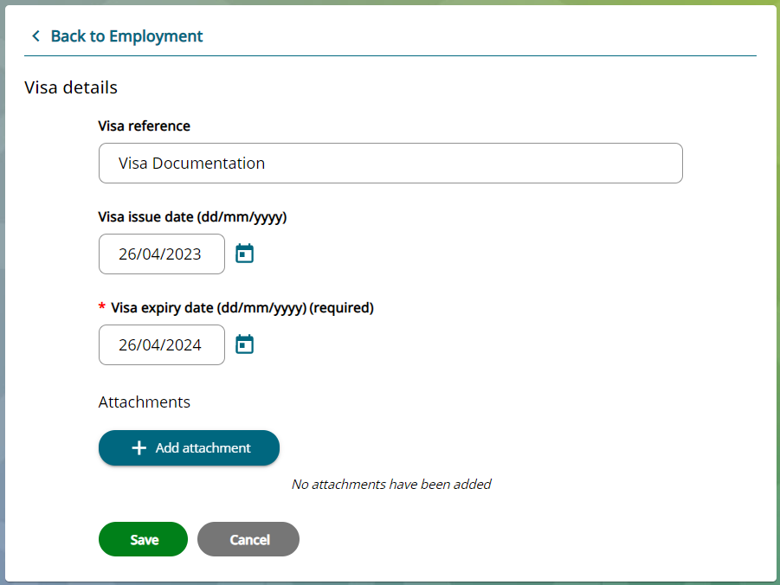

1. This will take you to a new document attachment details page.
2. Within the Document name, enter the document title – i.e., Visa Documentation.
3. Within the Document type select Visa.
4. Click on +Upload File.
5. You can either take a picture of your documents by using your phone’s camera or you can upload from your files.

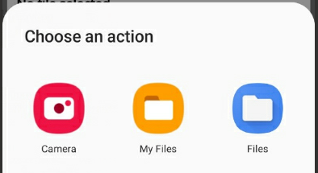

1. Once you have attached your Visa documents, click Save.
2. You can now see your document attachment within the Visa section, along the bottom of the page.

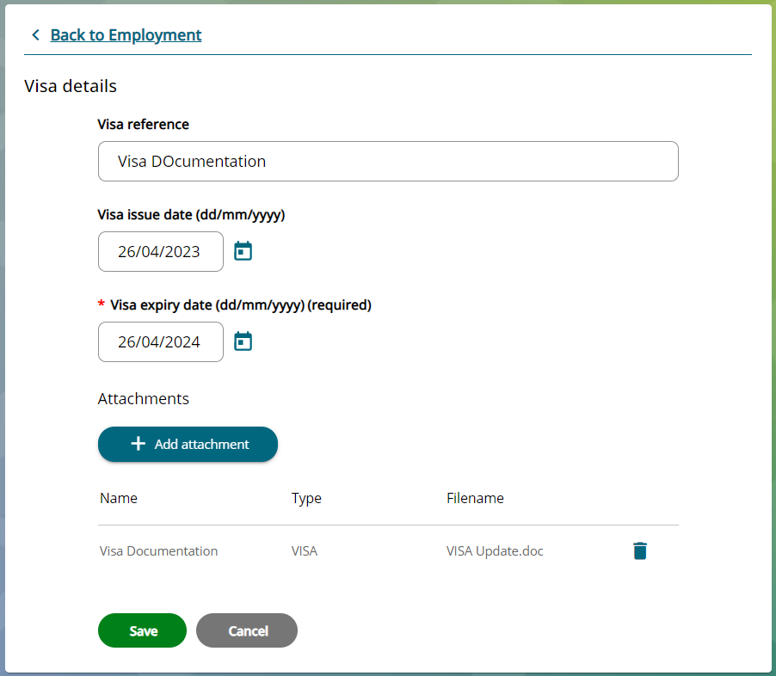

1. Click on the Save button to continue and conclude the process.

|  |  |  |  |
| --- | --- | --- | --- |
| Responsible (R) | Colleague Relations & Wellbeing | Accountable (A) | Human Resources |
| Consult (C) | Business Solutions | Inform (I) | All Business Units |
| Date | 18/08/2023 | Version | 1.0 |

1. An email will be sent to Colleague Relations confirming that you have attached Visa documents.