ESS - Case Management within Employee Self Service QRG

Opening a new case within Case Management.

1. Within the home page, click on View Profile.
2. Within your profile, click on the Employment tab, which can be located on the top bar.
3. Locate the Case Management section and click on + Add Case.
4. Select from the drop-down list:

* Flexible working – formal
* Grievance – informal (This is to inform HR that you would like to discuss your concerns)
* Questionnaire Form - feedback

1. Enter the detail within the title section.
2. Within the description (required) enter as much detail as you feel relevant to the case you are raising.
3. When you are comfortable that the details you’ve added are correct, click save.
4. When you click save a message will appear and you will be asked to either confirm or cancel.
5. Click confirm to continue or click cancel to return to the record detail.
6. When you press confirm, the record will appear in grey, and you can no longer add to or amend the details.
7. This record will now be sent to Colleague Relations, who will respond to your case in due course.
8. All new cases created, will be visible within the Case Management section and the status will show as new.

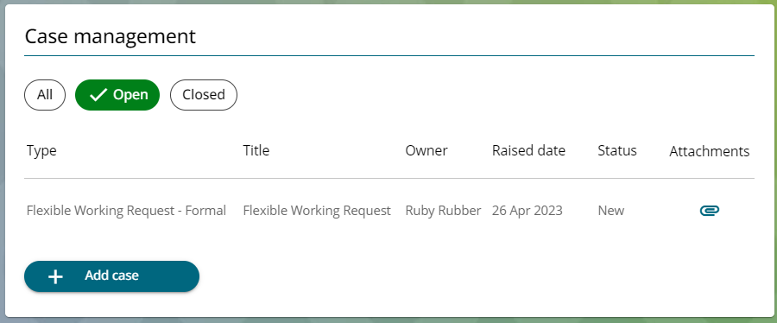

1. You can click on the case to view the details at any time.
2. You can also attach documents to the open case by clicking on the paperclip. *Refer to* *WFM - Attaching a Document in Case Management (ESS) QRG.*

Case Closed

1. When the case has been concluded, the case will be closed by Colleague Relations and the status will change to closed.
2. You can view your historic cases by clicking on the closed button.
3. Within the home page, you can also view your case history status.

|  |  |  |  |
| --- | --- | --- | --- |
| Responsible (R) | Colleague Relations & Wellbeing | Accountable (A) | Human Resources |
| Consult (C) | Business Solutions | Inform (I) | All Business Units |
| Date | 18/08/2023 | Version | 1.0 |

