ESS - Expense Claim Time & Expenses QRG

How to process an expense claim within Employee Self-Service (ESS).

1. Within the home page, click on My pay.
2. Within My pay, click on the Time & Expenses tab, which can be located on the top bar.

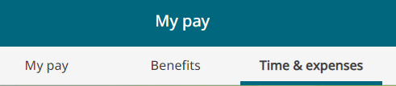

1. Click on the + Add claim button.

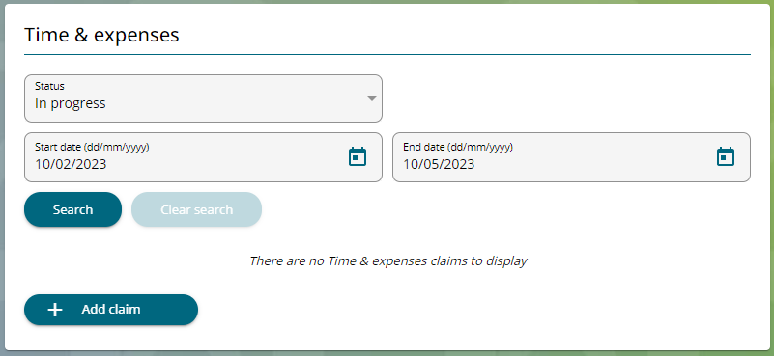

1. Within the start date box, enter the date you are creating the expense record.
2. Your Job title will automatically populate.
3. Within the claim template, select Expenses.

1. Click on the New button.

**Expense Claim Form**

1. Within the element section, use the drop-down menu and select the reason for your expense claim.

1. Enter the date that your expense took place.
2. Within the receipt attached section, enter a Y for Yes, all expense claims must have a receipt attached, where possible.
3. Enter the detail for your expense and the amount you are claiming for.

1. To add another claim, click on the plus sign and follow the same process as above.
2. When you are comfortable that the details are correct, click Submit. If you wish to print your claim, you must do this before clicking submit.



1. Read through the expense claim details, making sure that everything has been recorded correctly.
2. On occasion, you will be asked to enter your password during the expense process, this will be your log-on password that’s used for accessing Employee Self Service.

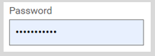

1. Below the password section, click on the add receipt attachments.



1. Select Expense Receipts from within the drop-down list.

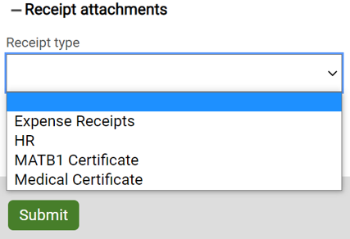

1. Choose the file you would like to attach or take a photo if you are using your mobile device.

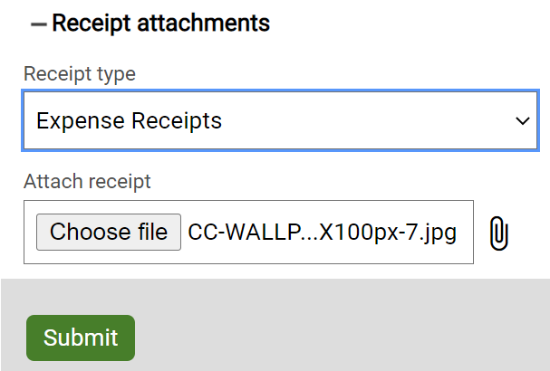

1. When you are ready to continue, click Submit.
2. The expenses claim will now show as awaiting authorisation. Once your manager has either authorised or not authorised the expense the status will change to reflect this, and you will also receive an email confirming the manager’s action.

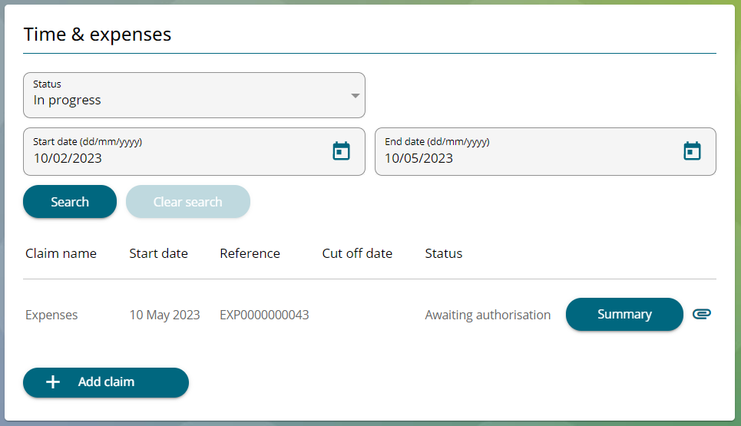

|  |  |  |  |
| --- | --- | --- | --- |
| Responsible (R) | Colleague Relations & Wellbeing | Accountable (A) | Human Resources |
| Consult (C) | Business Solutions | Inform (I) | All Business Units |
| Date | 18/08/2023 | Version | 1.0 |