ESS - Holiday Booking QRG

Booking and maintaining your holidays within Employee Self Service (ESS).

New Holiday Request – Part Day

1. Within the home page locate the holiday section and click on book holiday.

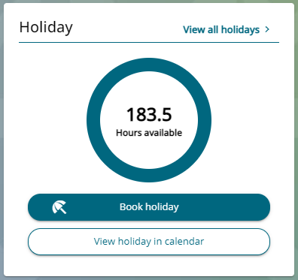

1. The absence type will auto populate.
2. Within the holiday period drop down list, select part day.
3. Within the start date box, enter the holiday date.

If you select either the morning or afternoon, your contracted hours for that day will be divided.

If you select specify time, you can enter the number of hours required on that part day request.

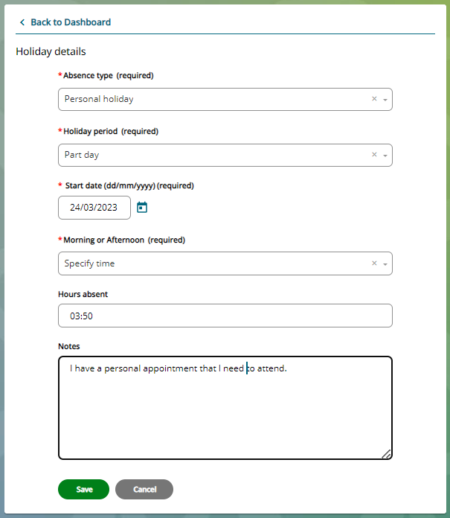

New Holiday Request – Full Day

1. Within the holiday period drop down list, select full day.
2. Within the start date box, enter the holiday date.

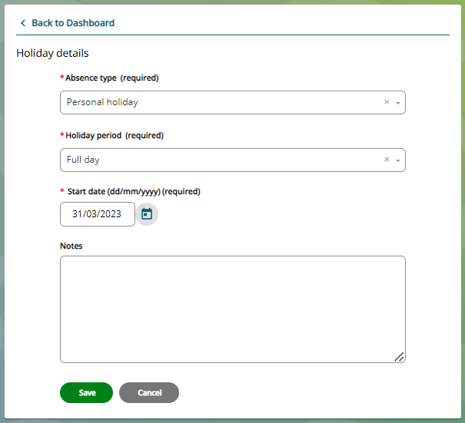

New Holiday Request – More than one day

1. Within the holiday period drop down list, select more than one day.
2. If you select more than one day, you will need to enter the start and end date of the holiday.

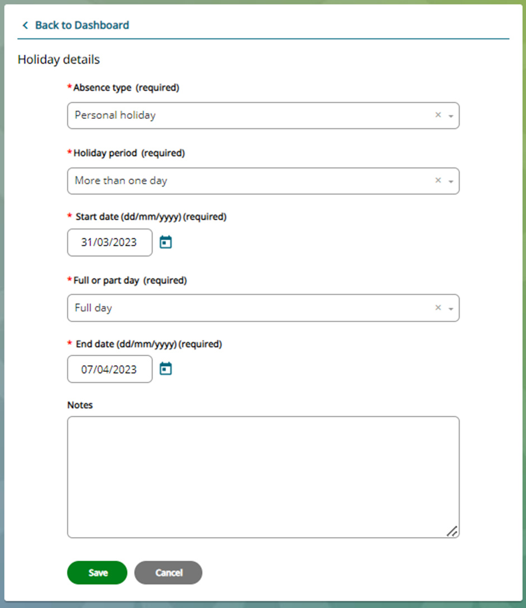

1. The notes section is optional.
2. Once you have completed your holiday request, click the save button.
3. When you click save, the below message will appear, giving you the option to go back to the dashboard or book another holiday.

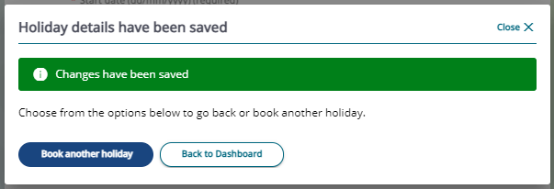

1. You will receive an email confirming the holiday request.
2. Your manager will also receive an email with your holiday request and any notes that you have recorded within the holiday record.
3. All holidays can be viewed within the holiday calendar or within the home page events calendar.
4. Within the view all holidays list, you can view your holiday status - awaiting authorisation or authorised.

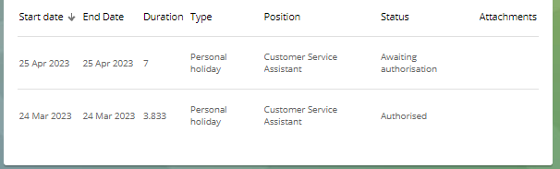

Holiday authorised

1. When your manager has authorised your holiday request, you will receive an email to confirm.
2. Within you holiday records the status will update and will show as authorised.

**Holidays not authorised**

1. Your manager will discuss the reasons as to why on this occasion they are not able to authorise your holiday.
2. You will receive an email confirming that the holiday has not been authorised.

**Amending a holiday record**

Following a discussion with your manager, complete the following steps.

1. Locate the authorised holiday record within view all holidays.
2. Click on the holiday record and make the required amendments – date, hours and/or duration.
3. Click save to confirm the amendments.
4. On amending a holiday record, an email will be sent to your manager confirming the changes made to the holiday record.
5. When your manager has authorised your amended holiday request, you will receive an email to confirm.
6. Within your holiday records list the status will update and will show as authorised.

**Deleting a holiday record**

Following a discussion with your manager, complete the following steps.

1. Locate the authorised holiday record within view all holidays.
2. Click on the holiday record and scroll down to the bottom of the page, click on the delete button.
3. When you have clicked delete, a message will appear.
4. Click confirm to continue with the cancellation or return to the holiday record.
5. On cancelling a record, an email will be sent to your manager confirming that you have deleted a holiday record.
6. Your holiday balance will be recalculated according to your entitlement.

|  |  |  |  |
| --- | --- | --- | --- |
| Responsible (R) | Colleague Relations & Wellbeing | Accountable (A) | Human Resources |
| Consult (C) | Business Solutions | Inform (I) | All Business Units |
| Date | 21/07/2023 | Version | 1.0 |