ESS - Informal Grievance QRG

Raising an Informal Grievance case within Employee Self-Service (ESS).

**Opening a new case within Case Management**

1. Within the home page, click on View Profile.
2. Within your profile, click the Employment tab on the top bar.



1. Scroll down and locate the Case Management section.
2. Click on + Add Case to create a new record.
3. Select from the drop-down list > Grievance informal.
4. Within the title section enter Grievance.
5. Within the description section, enter as much detail as you feel relevant to the case you are raising.
6. Before you save, ensure you have recorded everything that’s relevant to the issue being raised informally.

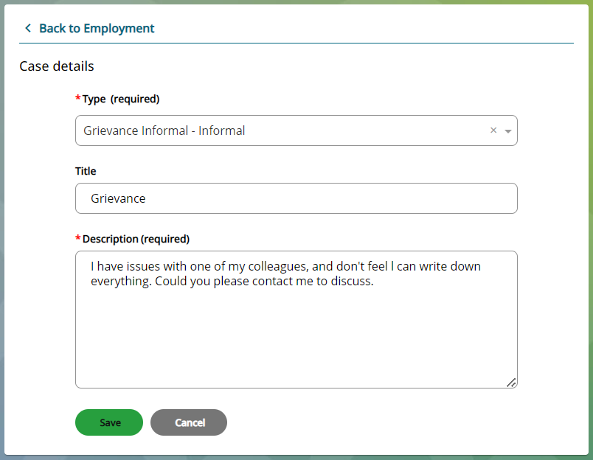

1. Click save.
2. A message will appear, and you will be asked to either confirm or cancel.

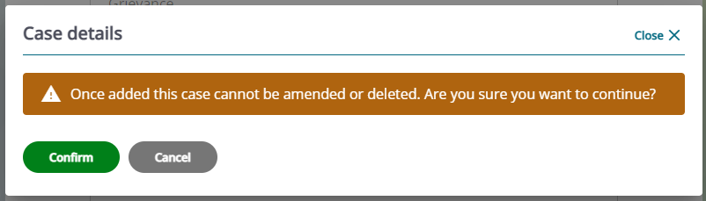

1. Click confirm to continue or click cancel to return to the record.
2. When you press confirm, the record will appear as read only, and you can no longer add or amend the details.
3. This request will now be sent to Colleague Relations, who will respond to your case in due course.
4. All open cases created, will be visible within the Case Management section and the status will show as new.

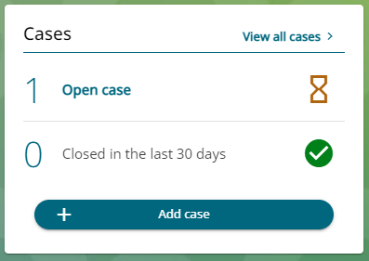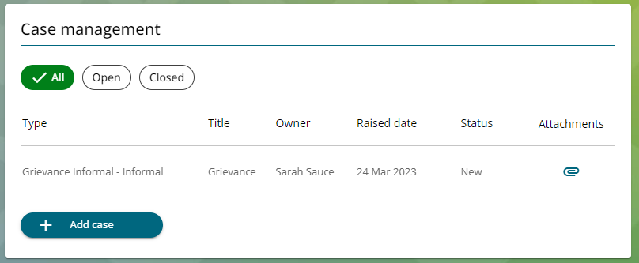

1. You can click to view the details at any time.
2. You can also attach documents to an open case by clicking on the paperclip. Follow the *Attaching a Document in Case Management (ESS) QRG process.*

**Case Closed**

1. When the case has been concluded, the case will be closed by Colleague Relation’s.
2. You can still view closed cases, either by pressing the All button or the Closed button.
3. Within these pages you can view all historic cases and any attachments that relate to the case that you have previously been attached.

|  |  |  |  |
| --- | --- | --- | --- |
| Responsible (R) | Colleague Relations & Wellbeing | Accountable (A) | Human Resources |
| Consult (C) | Business Solutions | Inform (I) | All Business Units |
| Date | 18/07/2023 | Version | 1.0 |