ESS - Mileage Claim QRG

How to process a mileage claim within Employee Self-Service (ESS)

1. Within the home page, click on My pay.
2. Within My pay, click on the Time & Expenses tab, which can be located on the top bar.
3. Click on the + Add claim button.

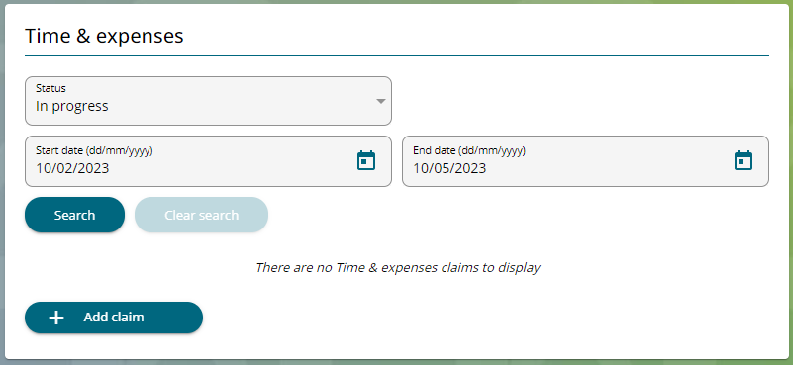

1. Click on the + Add claim button.
2. Within the start date, enter the date you are creating the expense record.
3. Your Job title will automatically populate.
4. Within the claim template, select Expenses.

1. Click on the New button.
2. Within the new record, click on Page 2 to raise a mileage claim.

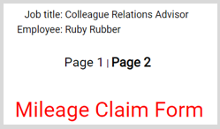

1. Enter your vehicle and fuel type, and the engine cc.

1. Enter the journey date, miles you’re claiming for, journey from and journey to and reason details.
2. When you have completed all the details, click Submit. If you wish to print your claim, you must do this before clicking submit.
3. On occasion, you will be asked to enter your password during the expense process, this will be your log-on password that’s used for accessing Employee Self Service.

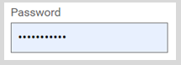

1. Read through the mileage claim details, making sure that everything has been recorded correctly.
2. Below the password section, click on the add receipt attachments.



1. All mileage claims must have a receipt attached, where possible.
2. Attach your receipt and click submit.

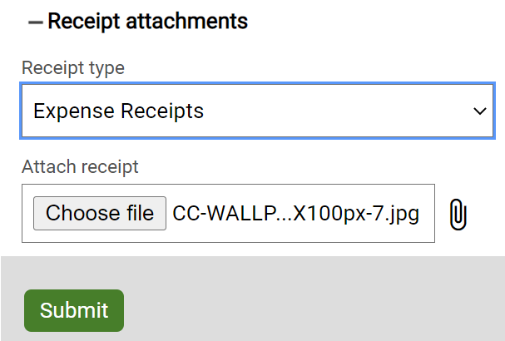

1. When you are ready to continue, click Submit.
2. The expenses claim will now show as awaiting authorisation. Once your manager has either authorised or not authorised the expense the status will change to reflect this, and you will also receive an email confirming the manager’s action.

|  |  |  |  |
| --- | --- | --- | --- |
| Responsible (R) | Colleague Relations & Wellbeing | Accountable (A) | Human Resources |
| Consult (C) | Business Solutions | Inform (I) | All Business Units |
| Date | 25/05/2023 | Version | 1.0 |