ESS - My Correspondence QRG

How to view your correspondence records within Employee Self-Service (ESS).

1. Within the home page, click on View Profile.

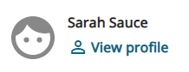

1. Within your profile, click on the Employment tab on the top bar.

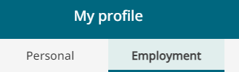

1. Scroll down the page and locate My Correspondence.
2. To view all your letter correspondence, remove the dates from the start and end boxes and click on the search button.
3. Alternatively, you can enter dates if you are searching for a particular date range.
4. All correspondence is listed and will show you a creation date and the status.

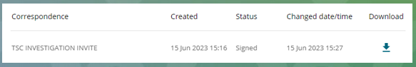

1. You can click on the letter title to read, download, or print.
2. Alternatively, you can download the letter, by clicking on the download icon.
3. Within each letter at the bottom of the page you will be able to view the signature details (name, date, and time of when the letter was signed).

|  |  |  |  |
| --- | --- | --- | --- |
| Responsible (R) | Colleague Relations & Wellbeing | Accountable (A) | Human Resources |
| Consult (C) | Business Solutions | Inform (I) | All Business Units |
| Date | 18/08/2023 | Version | 1.0 |

