ESS - Password & Memorable Information QRG

How to change and update your password and memorable information within Employee Self Service (ESS).

**How to change your password**

1. Within the home page, click on your utility menu within the top bar.



1. Within the drop-down list, click on settings.
2. Select change password within the drop-down menu.

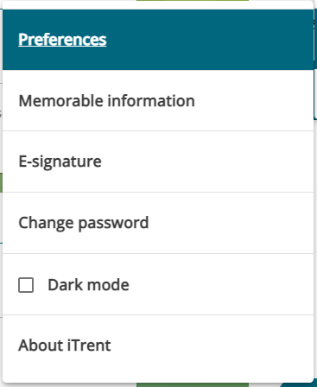

1. Within the change password page, complete the following fields.

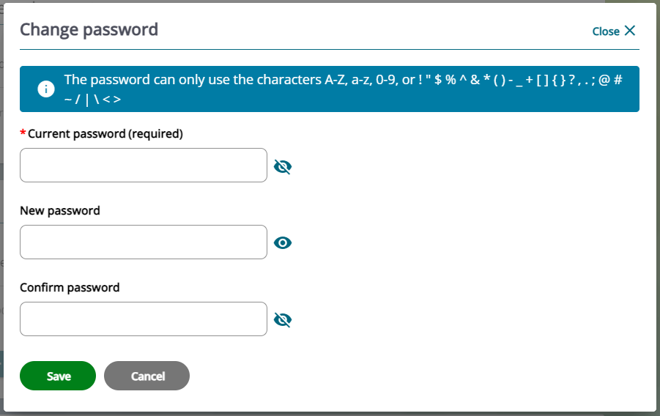

1. You can choose to show the details whilst you’re entering your current and new passwords, or you can continue with the details hidden.
2. Click on the save button.
3. Once you have clicked save, the following message will appear.
4. Click close to return to the home page.

**How to change your memorable information**

1. Within the home page, click on your utility menu.
2. Within the drop-down list, click on settings.
3. Select memorable information within the drop-down menu.
4. Within your memorable information details page, complete all the information required.
5. Make sure you use a prompt that is easy to remember.

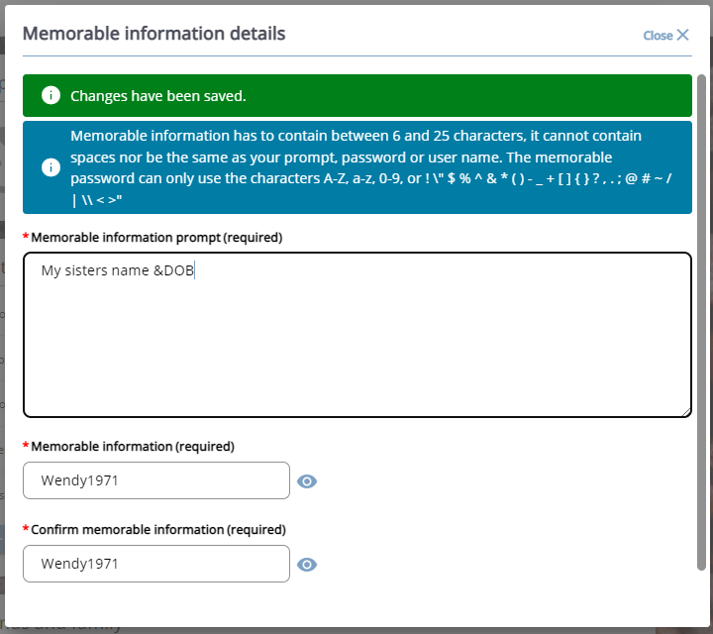

1. Click on the save button.
2. Once you have clicked save, the following message will appear.



1. Click close to return to the home page.

|  |  |  |  |
| --- | --- | --- | --- |
| Responsible (R) | Colleague Relations & Wellbeing | Accountable (A) | Human Resources |
| Consult (C) | Business Solutions | Inform (I) | All Business Units |
| Date | 18/07/2023 | Version | 1.0 |