ESS - Questionnaire Forms within

Requests & Surveys

How to view your questionnaire forms within Employee Self-Service (ESS).

1. All questionnaire forms can be located within your Requests & Surveys.
2. Within the home page you have a Request & Surveys section, you can also access Requests & Surveys within your profile or from within the utility menu.
3. Click on view requests & surveys to view your questionnaire forms.

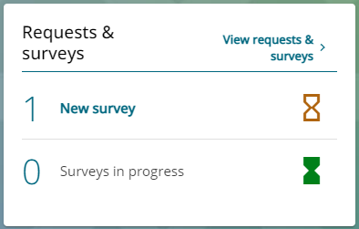

1. Within the requests & surveys section, you can view all, new, current, in progress and completed questionnaire forms.

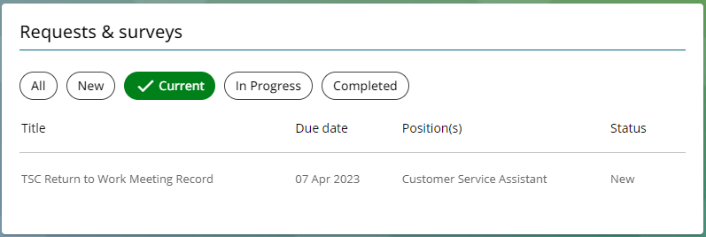

1. To view the content of a questionnaire form, click on the questionnaire title.
2. If the questionnaire form has been completed by your manager, you can view and read the content.
3. If the questionnaire has been attached to your profile, on your request, you will need to complete all the sections and save.
4. Once saved, a submit button will appear within the summary page.
5. Click on the submit button. Once you have clicked on the submit button, a message will appear to confirm completion.

|  |  |  |  |
| --- | --- | --- | --- |
| Responsible (R) | Colleague Relations & Wellbeing | Accountable (A) | Human Resources |
| Consult (C) | Business Solutions | Inform (I) | All Business Units |
| Date | 18/072023 | Version | 1.0 |