ESS - Raising a Flexible Working Request QRG

Raising a Flexible Working Request within Employee Self-Service (ESS).

**Opening a new case within Case Management**

1. Within the home page, click on View Profile.
2. Within your profile, click on the Employment tab, which can be located on the top bar.



1. Scroll down and locate the Case Management section.
2. Click on + Add Case to create a new record.
3. Select from the drop-down list: Flexible Working Request – Formal.

1. Within the title section enter Flexible Working Request.

1. Within the description section, enter as much detail as you feel is relevant to the request you are raising.
2. Before you save, ensure you have noted everything that’s relevant and that you’re comfortable with the detail.

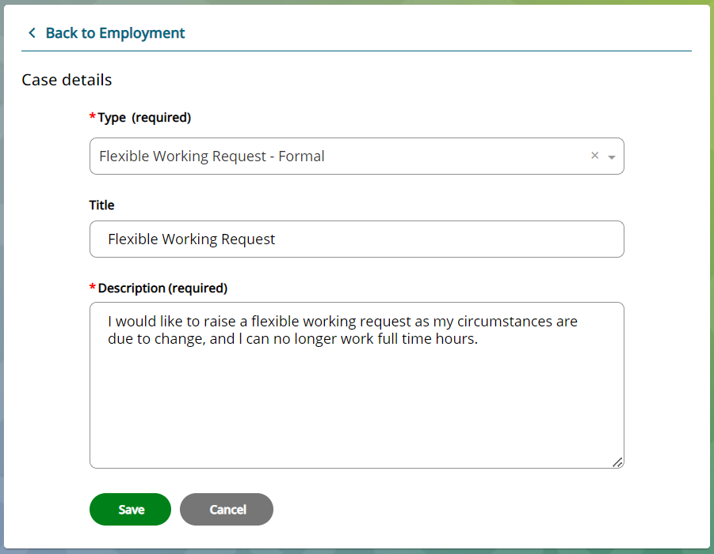

1. Click Save.
2. A message will appear, and you will be asked to either confirm or cancel.
3. Click confirm to continue or click cancel to return to the record.
4. When you press confirm, the record will appear as read only, and you can no longer add or amend the details.
5. This request will be sent to Colleague Relations, who will respond to your flexible working request in due course.
6. All open cases created, will be visible within the Case Management section and the status will show as new.

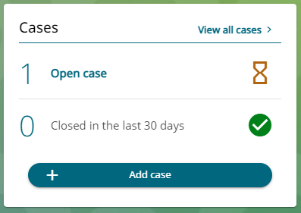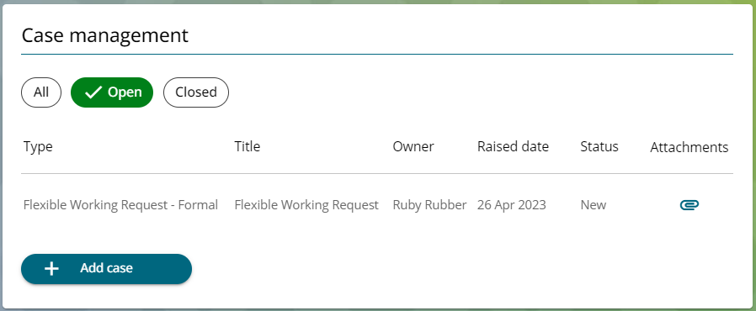

1. You can click on the case raised to view the details.
2. You can also attach documents to an open case by clicking on the paperclip. *Refer to WFM - Attaching a Document in Case Management (ESS) QRG.*

Case Closed

1. When the case has been concluded, the case will be closed by Colleague Relations.
2. You can still view closed cases, either by pressing the All button or on the Closed button.
3. Within these pages you can view all historic cases and any attachments that relate to the case that have previously been attached.

|  |  |  |  |
| --- | --- | --- | --- |
| Responsible (R) | Colleague Relations & Wellbeing | Accountable (A) | Human Resources |
| Consult (C) | Business Solutions | Inform (I) | All Business Units |
| Date | 18/08/2023 | Version | 1.0 |