ESS – Timesheet ELS QRG

How to process a Timesheet within Time and Expense - Employee Self-Service (ESS).

1. Within the home page, click on My pay.
2. Within My pay, click on the Time & Expenses tab, which can be located on the top bar.
3. Click on the + Add claim button.

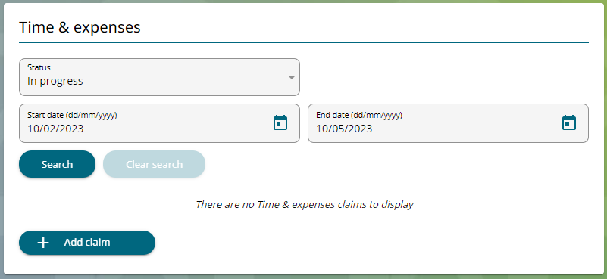

1. Within the start date box, enter the date you are creating the time claim record.
2. Your Job title will automatically populate.
3. Within the claim template, select ELS Timesheet, you will only see the timesheet that is applicable to you. In this example we will use Timesheet 1.

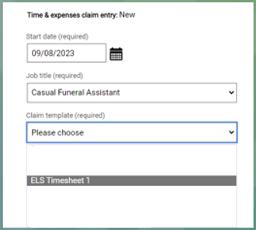

1. Click on the new button.

**Expense Claim Form**

1. Within the element section, use the drop-down menu and select the overtime that you are claiming. Select the one that is relevant to the claim you are making.

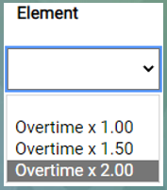

1.00 - Time

1.50 - Time & half

2.00 - Double time

1. Within the reason box enter a reason as to why you are claiming the overtime you have selected.

1. Within the Branch Name section, you can leave this blank if there is no charge. If you need to charge the cost to another branch, click on the magnifying glass to search for the branch and select.

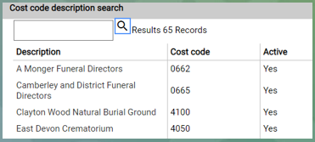

1. Enter the detail in the correct days for the hours you are claiming.

**Note:** You must remember this needs to be entered as hours decimal not hours & minutes. 0.25 = 15 minutes 0.50 = 30 minutes and 0.75 = 45 minutes

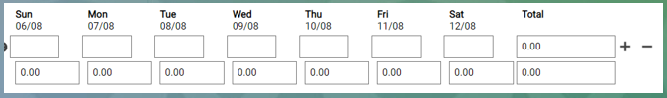



1. To add another claim, click on the plus sign and follow the same process as above.
2. You will **only** be able to see the timesheet for that current week, you will not be able to submit a timesheet in advance.
3. You can update your claim form daily, to save the details select **save draft.** Only select submit when your claim form has been completed for that current working week.

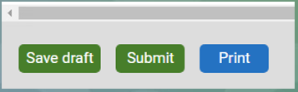

1. On completion, you will be able to see your total hours claimed. Make sure you sense check the totals before submitting the claim.
2. You may need to claim other payments for example removals standby etc. If you do, follow the next steps for Page Two.

**Page Two**

1. Select Page 2 within the same claim form you are currently using.

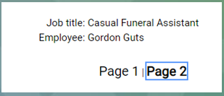

1. Within the Element box select from the drop-down list.

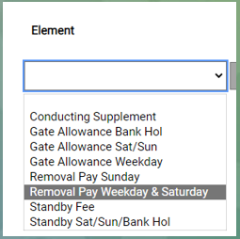

1. Within the reason box, enter the reason for the claim, this is a free text box.

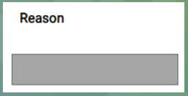

1. Within the Branch Name section, you can leave this blank if there is no charge. If you need to charge the cost to another branch, click on the magnifying glass to search for branch and select.
2. Throughout the week, you need to enter how many removals you have done on that day, for all elements you only need to enter the number of units and not hours.

***Example***

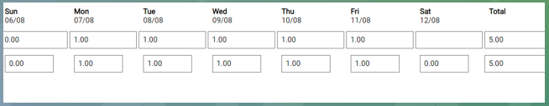

1. If you need to enter more elements click on the + sign to add another line.
2. You can update your claim form daily, to save the details select **save draft.** Only select submit when your claim form has been completed for that current working week.



1. If you have saved the timesheet in draft, locate the provisional T&E record, and continue to update before submitting the claim for that week.

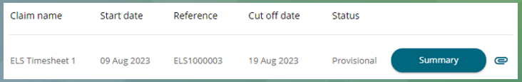

1. Read through the expense claim details – **Pages 1 & 2**, making sure that everything has been recorded correctly.
2. When you are comfortable that you have entered all the details required, click Submit.

If you wish to print your claim, you must do this before clicking submit.

1. On occasion, you will be asked to enter your password during the Time Claim process, this will be your log-on password that’s used for accessing Employee Self Service.

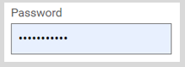

1. When you are ready to continue, click Submit.
2. Your claim record will now show as awaiting authorisation. Once your manager has either authorised or not authorised your claim the status will change to reflect this, and you will receive an email confirming the manager’s action.

|  |  |  |  |
| --- | --- | --- | --- |
| Responsible (R) | Payroll Department | Accountable (A) | Human Resources |
| Consult (C) | Business Solutions | Inform (I) | End of Life Services |
| Date | 14/08/2023 | Version | 1.0 |